## Composting

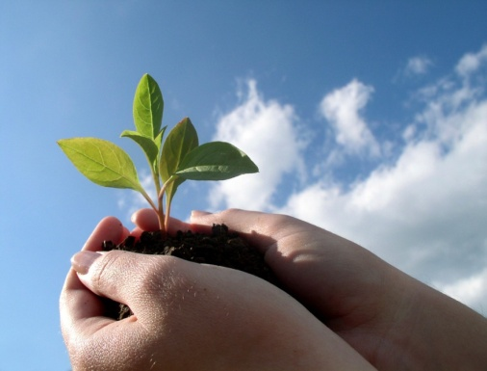

Yard trimmings and food waste together constitute 24% of the waste sent to U.S. landfills -- a lot to waste when it could become useful and environmentally beneficial organic compost instead. Composting is also easy to do.

**What to Compost**

Animal manure

Cardboard rolls and clean paper

Coffee grounds and filters

Cotton and wool rags

Dryer and vacuum cleaner lint

Eggshells and nut shells

Fireplace ashes

Fruits and vegetables

Grass clippings and leaves

Hair and fur

Hay and straw

Houseplants

Shredded newspaper

Tea bags

Wood chips and sawdust

Yard trimmings

**What Not to Compost**

Black walnut leaves or trimmings

Coal or charcoal ash

Dairy products

Diseased or insect-ridden plants

Fats, grease, lard, or oils

Meat or fish bones and scraps

Pet wastes

Yard trimmings treated with pesticides